Vikram Pai
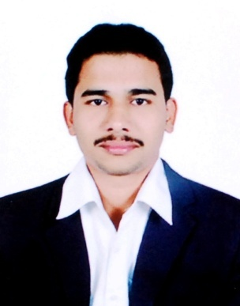
Obaleshwara Nilaya, No: 21, Door No: 4, 2nd floor,
3rd Cross, Jai Bheema Nagar, Old Madiwala,
BTM 1st Stage, Bangalore - 560068
Phone: +91 9945219304
E-mail ID: paivikramuk@gmail.com

CAREER OBJECTIVE
I am a management graduate from NMIT Bangalore (VTU) with specialization in Marketing. My career objective is to succeed in an environment of growth and excellence by applying my marketing skills and grow with the organization. In this process of growth, I am sure to gain immense experience with which I aspire to scale new heights personally and professionally and create a powerful image of myself to be identified with the organization.
EDUCATIONAL QUALIFICATION

Qualification | College / School  (University / Board) | Year of Passing | Specialization | Percentage /  CGPA
MBA | NMIT Bangalore,  VTU University | 2015 | Marketing | 67
BBM | Bhandarkars’ Arts and Science College, Mangalore University | 2012 | Finance | 55
XII | RNS PU College,  Kundapura | 2009 | Commerce  (CEBA) | 65
X | Govt. High School,  Uppinakudru | 2007 | SSLC Board | 75

PROJECT WORK
- A Study on Customer Satisfaction towards Doctor Module with reference to IQH Medicare Pvt. Ltd. Bangalore. The main objective of this project was to study and understand the level of customer satisfaction by using Doctor Module App.
- The duration of the project was for 10 weeks.

INDUSTRIAL VISITS
- Mysore Sandal Soap Factory
- PVC Pipe Industry
- Apollo Paints Industry

WORK EXPERIENCE AND CO-CURRICULAR ACTIVITIES

- Currently working as Key Account Executive in Systech Service Ltd from past 10months.
- Worked as Marketing Executive in Dolan Techno crafts Pvt ltd for 4 months.
- Internship at TANISHQ boutique as a counter assistant for the retail sales executives was a good experience of face to face customer interaction.
- Being appointed as Placement coordinator in college was a good opportunity to build strong relationship between students, college management and participating companies.
- Being active Member of Rotaract club gave enough exposure towards social responsibility.
- Participated in EDP (Entrepreneurship Development Program)work shop organized by Rotary club NMIT.

STRENGTHS

- Comprehensive problem solving skills
- Communications skills
- Ability to work independently & in a team environment.
- Efficient in planning & execution, smart work and self-motivated.

PERSONAL INFORMATION
Email : paivikramuk@gmail.com
Contact : +91 9945219304
Date of Birth : 08-04-1991
Sex : Male
Marital status : Single
Hobbies : listening music, Playing Cricket, Travelling, learning new things.
And web browsing
Language proficiency : English, Kannada, Hindi and Konkani
Permanent Address : Vikram pai
S/o Late Narayana Pai, Pai house, Uppinakudru, Kundapura
Pin code: 576230
Udupi District, Karnataka, India

Date: 15-01-2017 NAME
PLACE: BANGALORE VIKRAM PAI

